|  |  |  |
| --- | --- | --- |
| **C++ Programming** | **Student**  **number** | **21300691** |
| **Homework 3** | **Name** | **Cheung, Won Sik** |

Header file and Student structure that have name, id, room number, penalty point

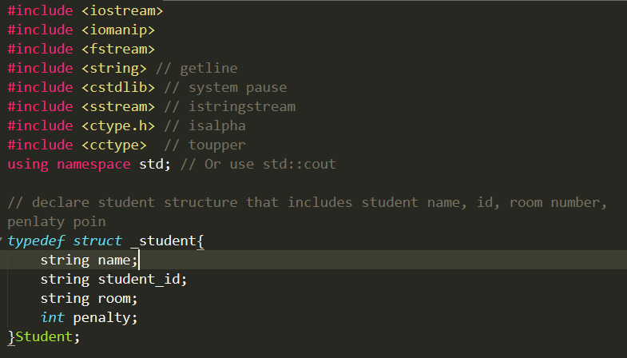

Dormitory class that have student list, number and methods

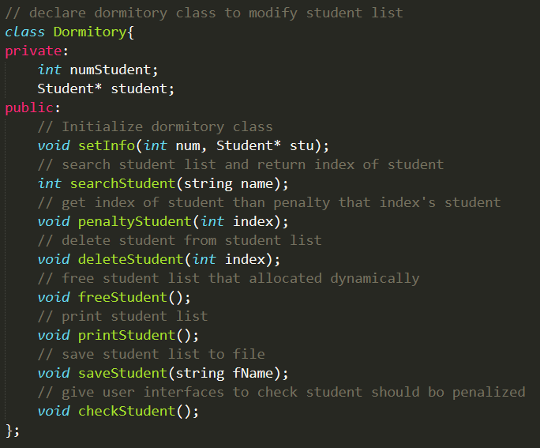

Functions that are used in main and other functions.

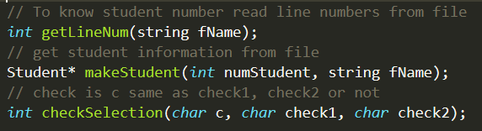

Main function

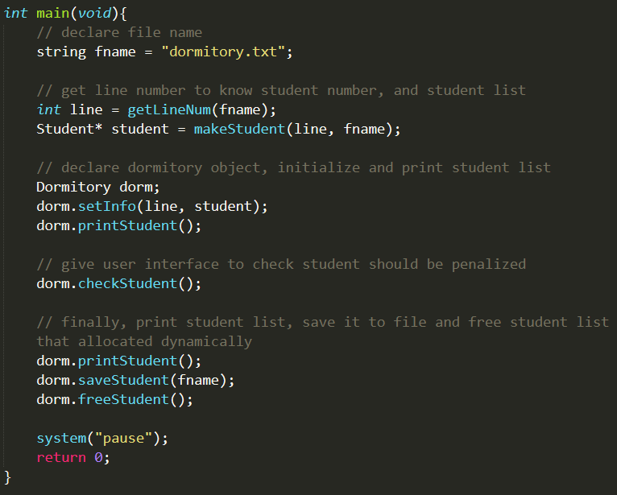

getLineNum function

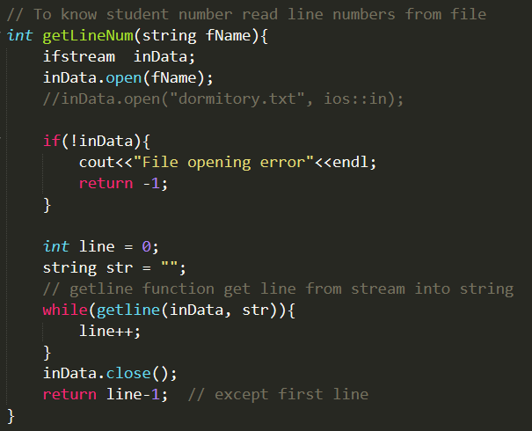

makeStudent function

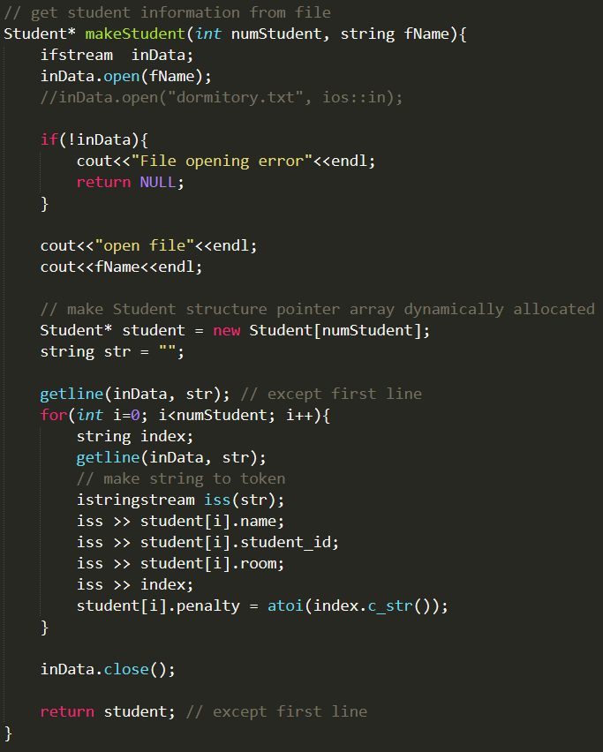

checkSelection function

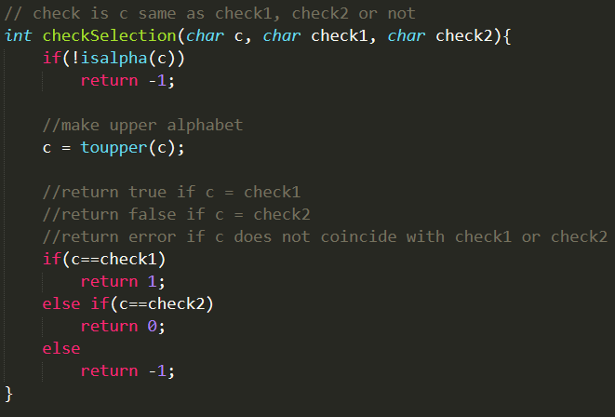

Dormitory::setInfo function

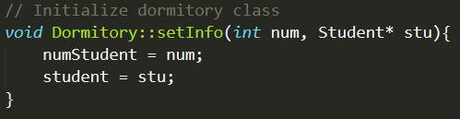

Dormitory::penaltyStudent function

Dormitory::deleteStudent function

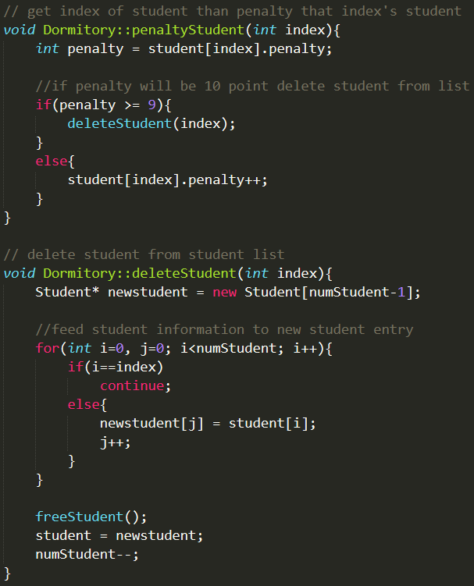

Dormitory::freeStudent function

Dormitory::printStudent function

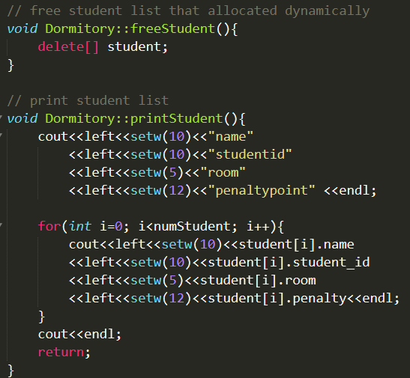

Dormitory::saveStudent function

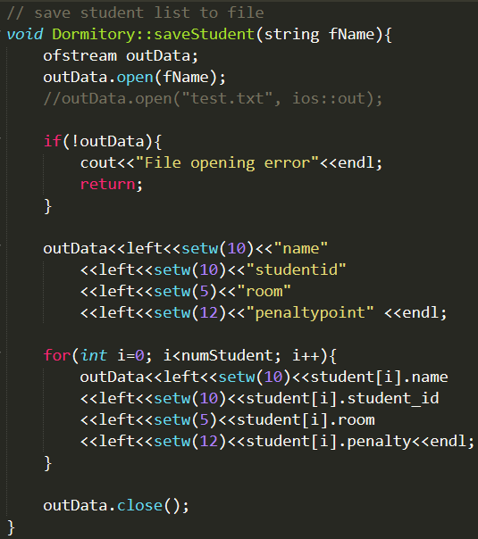

The selection of the user interface is configured as follows.

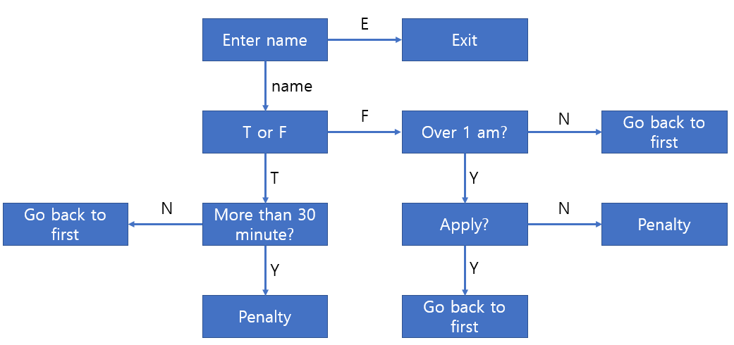

Dormitory::checkStudent function

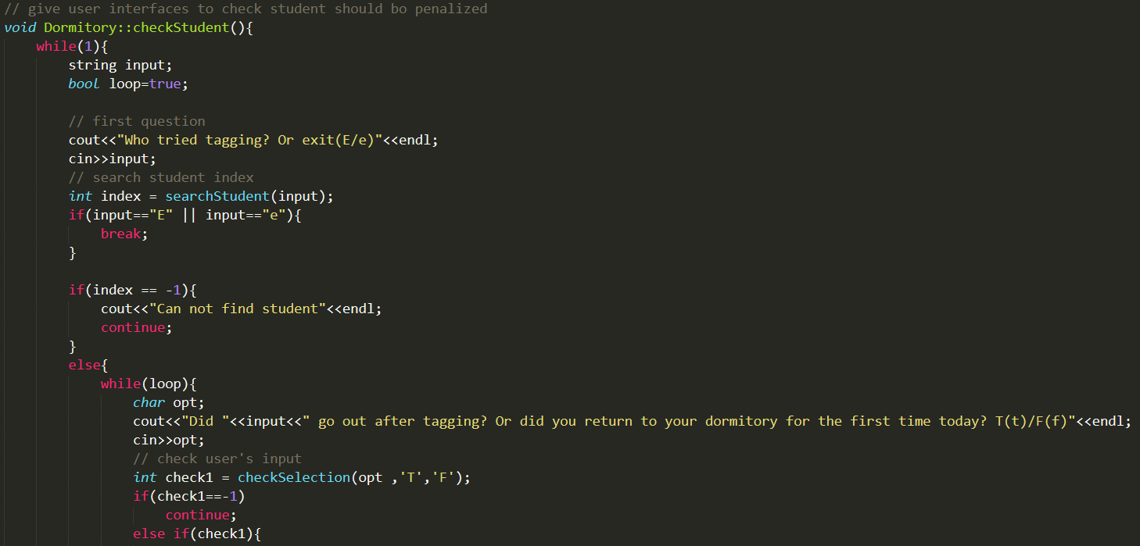 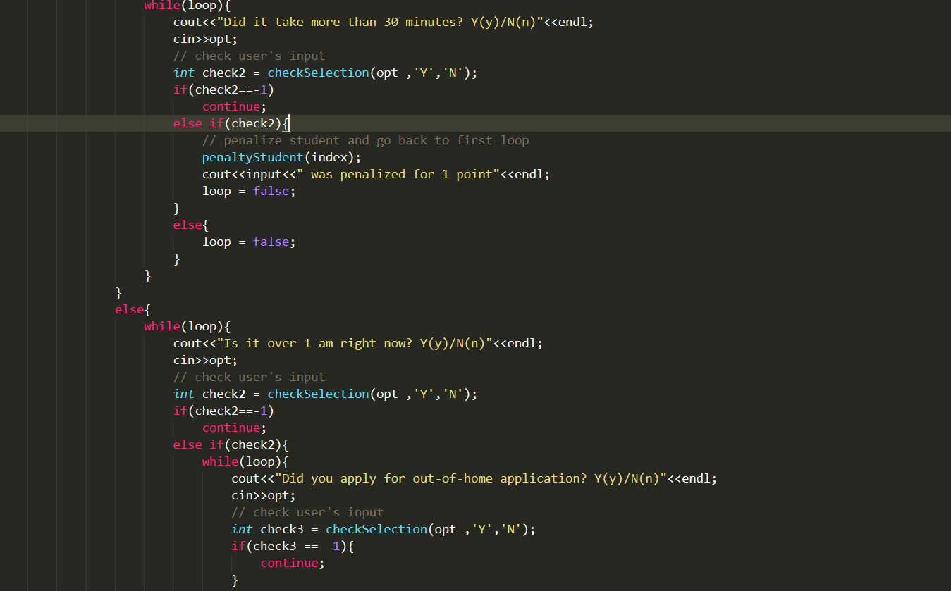

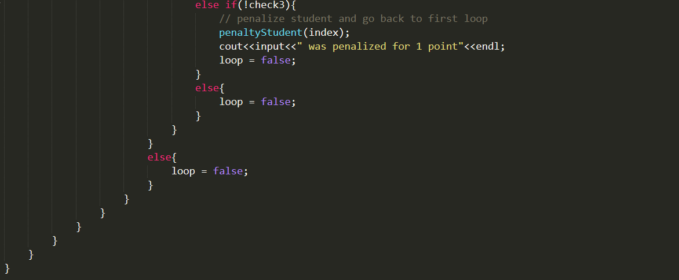

Result

